Table of Contents
1. Executive Summary 2
2. Testing Objectives 2
3. Types of Testing 3
4. Functional Testing 3
4.1 Objective 3
4.2 Test Data Used 3
4.3 Validation Checks 4
5. Unit Testing 5
5.1 Objective 5
5.2 React Unit tests: 5
5.3 FastAPI Unit tests 5
5.3.1 Frameworks and Libraries Used 6
5.3.2 Test Execution Summary 6
6. API Testing 9
6.1 Objective 9
6.2 Request/response schema validation 10
6.3 Status code and messages 10
6.4 Authentication and Authorization on endpoints 13
6.5 Swagger UI 14
7. Load Testing 17
7.1 Objective 17
7.2 Test Scope and Methodology 18
7.3 Evidence Artifacts (Captured Reports & Charts) 18
7.4 Run-by-Run Load Test Results 19
7.5 Key Reliability Outcomes 19
7.6 Endpoint Reliability Snapshot (Final Run – 125 Users) 19
7.7 Test summary and outcome 20
8. Database & Migration Testing 20
8.1 Objective 20
8.2 Migration Approach 21
8.3 Data Validation 21
8.4 Utilities test 22
8.5 Schema Validation 24
8.6 Data Correctness Sampling 27
9. Security Testing: 29
10. Integration Testing: 32
10.1 /health API endpoint 32

TEST STRATEGY DOCUMENT

Project Name: Tool Migration – VB Forms to React/FastAPI/Azure
Version: 1.0
Prepared By:
Date:
Approval:

Executive Summary
This document defines the test approach, scope, methodology, environments, and governance for migrating the legacy VB Forms application (on-prem SQL Server) to a modern cloud-based architecture using:
- React.js (Frontend)
- FastAPI (Service Layer)
- Azure SQL (Database)
The objective is to ensure:
- Functional parity
- Data integrity
- Performance stability
- Security compliance
- Cloud reliability
- Regression safety

Testing Objectives

- Ensure 100% business feature coverage
- Validate migrated data accuracy
- Validate service/API correctness
- Confirm cloud deployment readiness
- Detect regression defects early
- Ensure production-grade reliability

Types of Testing
The following types of testing were carried out as part of the SAC and Affinity application validation. Each testing type is mapped to the corresponding section within this document for easy reference.

S. No. | Type of Testing | Section
1 | Functional Testing (Core) , UI Testing (React) | 4
2 | Unit Testing (React + Fast API) | 5
3 | API Testing (Fast API Layer) | 6
4 | Load testing | 7
6 | Database & Migration Testing | 8
7 | Security Testing | 9
8 | Integration Testing | 10

Functional Testing

Objective

Goal: Validate features match requirements and legacy behavior.
Includes:
- Feature-based testing: each module/workflow
- Workflow testing: end-to-end business flows
- Role-based testing: permissions & access paths
- Error handling: validation, warnings, exception flows
Key migration focus: Identify “hidden behaviors” in VB Forms (e.g., implicit validations, default values, auto-calculations triggered on field change).

Test Data Used
- Existing Customer Data
- Existing customer accounts and program Name were used, data was compared between VBA and web application.
- No Modifications were made for comparison testing.
- Modified records for Validation Few selected customers were intentionally modified, used to validate field checks, business justifications, triggers and submission restrictions.
- Dummy Customer Records Created new applications for workflow validations, tested end-to-end movement across roles.

Detailed Validation rules and test Scenarios executed during testing are documented in the supporting excel file and can be referred to for complete understanding: SAC VBA DOC.xlsx

Table: Test Data Summary
Vertical | Account Name/Program Name | Testing Purpose | Data Modification
SAC | Union College-Trustees of | UI & Value Comparison | No changes Made
SAC | 4M Capital LTD dbaArteriors Home | UI & Value Comparison | No changes Made
SAC | A’Gaci LLC | UI & Value Comparison | No changes Made
SAC | Alliance Shippers Inc | UI & Value Comparison | No changes Made
SAC | Big boy Restaurants International LLC | UI & Value Comparison | No changes Made
SAC | Tennis Corporation of America | UI & Value Comparison | No changes Made
SAC | True Friends | Mandatory field/Logics/Triggers Validation | Values Modified
SAC | Roedel Companies | Mandatory field/Logics/Triggers Validation | Values Modified
Affinity | Kanha Hotel Programs | UI & Value Comparison | No changes Made
Affinity | Fortress Dental Affinity Program | Mandatory field/Logics/Triggers Validation | Values Modified
Affinity | Big Brother Big Sister of America | Mandatory field/Logics/Triggers Validation | Values Modified
Affinity | Pet Services Program | UI & Value Comparison | No changes Made

Validation Checks
- UI consistency Validation
Verified alignment of screen layouts with legacy VBA system. Confirmed correct field visibility and formatting. Validated mandatory field and associated error messages.

- Data Consistency Validation
Compared field Level Values for identical customer number and program name, Verified total Premium calculation and derived values for accuracy.

- Business Logic Validations
Validated business rules during save and save & Exit by modifying selected variable inputs and observing system behavior. Confirmed expected trigger behavior

- Workflow Validation
Verified correct application progression across different stages, confirmed role-based access restriction (Underwriter, Director, Admin), verified saved data was available during role transactions
You can find the validation\Internal Testing performed in the following excels:

Excel Link | Description
SAC Testing | Data Comparison Validation using same customer number
SAC Bugs | Observations and Business Rule/Form Level issues identified during testing in SAC
Affinity Testing | Validation using same program name
Affinity Bugs | Observations and Business Rule/Form Level issues identified during testing in Affinity

Unit Testing

Objective
Unit test is an automated, isolated test that verifies a small, specific piece of software—such as a single function, method, or class—functions exactly as intended. It checks if defined inputs produce the expected outputs, providing fast feedback to developers, and ensuring code quality early in development.
Objective is to cover >=80% of the total statements as part of unit test cases, while covering negative scenarios as well. We also need to write unit test cases for exception handlings as well.

React Unit tests:
Need to add

FastAPI Unit tests
Unit tests have been implemented for the Python application using the pytest framework. The primary objective of these tests is to validate individual units of code in isolation, enabling the early and cost‑effective identification of defects. All major functions have been covered, including negative and edge-case scenarios, to ensure comprehensive verification of each component independently.

Frameworks and Libraries Used
- Test Framework: pytest
Used as the main testing framework to structure, organize, and execute unit tests.
- Coverage Reporting: pytest-cov
Utilized to measure code coverage and generate detailed coverage reports.
- Data Mocking: pytest-mock
Employed to mock external dependencies, enabling isolated and deterministic test behavior.
- Asynchronous Testing: pytest-asyncio
Used for testing asynchronous functions and ensuring correctness of async workflows.

Test Execution Summary
Below are the details of the test execution and overall coverage results. We have achieved total coverage of 87%, which is more than our objective of covering >=80%.

File | Stmts | Miss | Cover
core/models/sac_policies.py | 47 | 18 | 62%
services/auth_service.py | 121 | 37 | 69%
services/sac/loss_run_distribution_service.py | 33 | 9 | 73%
services/affinity/affinity_agents_service.py | 38 | 9 | 76%
services/sac/sac_account_service.py | 57 | 12 | 79%
services/dropdowns_service.py | 248 | 52 | 79%
services/sac/sac_policies_service.py | 124 | 26 | 79%
core/date_utils.py | 103 | 21 | 80%
services/affinity/policy_type_distribution_service.py | 35 | 7 | 80%
core/db_helpers.py | 157 | 29 | 82%
services/affinity/claim_review_distribution_service.py | 33 | 6 | 82%
services/affinity/loss_run_distribution_service.py | 33 | 6 | 82%
services/sac/claim_review_distribution_service.py | 33 | 6 | 82%
services/sac/deduct_bill_distribution_service.py | 33 | 6 | 82%
services/affinity/affinity_program_service.py | 54 | 9 | 83%
services/sac/sac_affiliates_service.py | 38 | 6 | 84%
services/sac/sac_account_associations_service.py | 93 | 12 | 87%
services/affinity/affinity_policy_types_service.py | 72 | 9 | 88%
core/encrypt.py | 18 | 2 | 89%
services/affinity/claim_review_frequency_service.py | 30 | 3 | 90%
services/affinity/loss_run_frequency_service.py | 30 | 3 | 90%
services/sac/deduct_bill_frequency_service.py | 39 | 3 | 92%
services/sac/loss_run_frequency_service.py | 43 | 3 | 93%
services/sac/claim_review_frequency_service.py | 44 | 3 | 93%
services/sac/hcm_users_service.py | 53 | 3 | 94%
core/config.py | 23 | 1 | 96%
services/validations/affinity_validations.py | 121 | 2 | 98%
__init__.py | 0 | 0 | 100%
api/affinity/affinity_agents.py | 15 | 0 | 100%
api/affinity/affinity_policy_types.py | 12 | 0 | 100%
api/affinity/affinity_program.py | 12 | 0 | 100%
api/affinity/claim_review_distribution.py | 18 | 0 | 100%
api/affinity/claim_review_frequency.py | 13 | 0 | 100%
api/affinity/loss_run_distribution.py | 16 | 0 | 100%
api/affinity/loss_run_frequency.py | 13 | 0 | 100%
api/affinity/policy_type_distribution.py | 13 | 0 | 100%
api/affinity/search_affinity_program.py | 7 | 0 | 100%
api/auth.py | 18 | 0 | 100%
api/dropdowns.py | 15 | 0 | 100%
api/outlook_compose.py | 8 | 0 | 100%
api/sac/claim_review_distribution.py | 18 | 0 | 100%
api/sac/claim_review_frequency.py | 13 | 0 | 100%
api/sac/deduct_bill_distribution.py | 18 | 0 | 100%
api/sac/deduct_bill_frequency.py | 13 | 0 | 100%
api/sac/hcm_users.py | 13 | 0 | 100%
api/sac/loss_run_distribution.py | 18 | 0 | 100%
api/sac/loss_run_frequency.py | 13 | 0 | 100%
api/sac/sac_account.py | 12 | 0 | 100%
api/sac/sac_account_associations.py | 16 | 0 | 100%
api/sac/sac_affiliates.py | 13 | 0 | 100%
api/sac/sac_policies.py | 20 | 0 | 100%
api/sac/search_sac_account.py | 7 | 0 | 100%
core/jwt_handler.py | 21 | 0 | 100%
core/models/__init__.py | 0 | 0 | 100%
core/models/affinity/__init__.py | 6 | 0 | 100%
core/models/affinity/affinity_agents.py | 7 | 0 | 100%
core/models/affinity/affinity_claim_review_frequency.py | 12 | 0 | 100%
core/models/affinity/affinity_distribution.py | 10 | 0 | 100%
core/models/affinity/affinity_loss_run_frequency.py | 13 | 0 | 100%
core/models/affinity/affinity_policy_types.py | 7 | 0 | 100%
core/models/affinity/affinity_program.py | 9 | 0 | 100%
core/models/auth.py | 4 | 0 | 100%
core/models/claim_review_frequency.py | 10 | 0 | 100%
core/models/deduct_bill_frequency.py | 5 | 0 | 100%
core/models/distribution.py | 9 | 0 | 100%
core/models/hcm_users.py | 8 | 0 | 100%
core/models/loss_run_frequency.py | 11 | 0 | 100%
core/models/outlook_compose.py | 11 | 0 | 100%
core/models/sac_account.py | 12 | 0 | 100%
core/models/sac_account_associations.py | 4 | 0 | 100%
core/models/sac_affiliates.py | 5 | 0 | 100%
core/outlook_compose.py | 23 | 0 | 100%
db.py | 39 | 0 | 100%
services/affinity/search_affinity_programs_service.py | 17 | 0 | 100%
services/sac/search_sac_account_service.py | 16 | 0 | 100%
services/validations/__init__.py | 0 | 0 | 100%
Totals | 2346 | 303 | 87%

API Testing

Objective

Goal: Ensure REST endpoints behave correctly.
Covers:
- Request/response schema validation
- Status codes and error messages
- Authentication/authorization on endpoints
- Idempotency (PUT/PATCH), concurrency behavior
Types
- Functional API tests
- Negative tests (invalid payloads, missing headers)
- Contract tests (React ↔ API agreement)

Request/response schema validation
The application uses Pydantic, the schema validation library integrated with FastAPI, to validate both API request and response data structures. Pydantic ensures that all incoming payloads conform to the expected schema, enforcing data types, required fields, and validation rules before any business logic is executed.
Each upsert and delete API endpoint is processed through these Pydantic validation models. Only after the request successfully passes validation does the system proceed with the corresponding database operation. This approach helps maintain data integrity, prevents malformed inputs, and ensures consistent behavior across all API endpoints.

Status code and messages
Each API endpoint implements specific success and error messages tailored to the type of data it processes. These messages are designed to provide clear, consistent, and actionable information to both the client application and end users.
The following table presents a comprehensive overview of the status codes, message descriptions, and associated file or module names.
HTTP Code | Message | Source
200 | Deletion successful | core/db_helpers.py; services/dropdowns_service.py
200 | Insertion successful | core/db_helpers.py; services/dropdowns_service.py
200 | Logged out successfully | services/auth_service.py
200 | No data provided | core/db_helpers.py; services/dropdowns_service.py
200 | No data provided for deletion | core/db_helpers.py; services/dropdowns_service.py; services/sac/sac_account_associations_service.py
200 | No data provided for insertion | core/db_helpers.py; services/dropdowns_service.py
200 | No new associations to add | services/sac/sac_account_associations_service.py
200 | Sign in successful | services/auth_service.py
200 | Token refreshed | services/auth_service.py
200 | Transaction successful | core/db_helpers.py; services/affinity/affinity_policy_types_service.py; services/dropdowns_service.py; services/sac/hcm_users_service.py; services/sac/sac_affiliates_service.py; services/sac/sac_policies_service.py
200 | Update successful | services/sac/sac_policies_service.py
200 | Upsert successful | services/dropdowns_service.py
200 | User authenticated | services/auth_service.py
200 | Welcome to SAC | app.py
200 | status: ok | app.py
400 | <primary_key> is required for deletion | services/dropdowns_service.py
400 | Affinity Program Name is a mandatory field | services/validations/affinity_validations.py
400 | Branch Office is a mandatory field | services/validations/affinity_validations.py
400 | Dropdown type is required | services/dropdowns_service.py
400 | Dropdown type must be specified | services/dropdowns_service.py
400 | Each row must be an object | services/dropdowns_service.py
400 | Each row must include data | services/dropdowns_service.py
400 | Field name and update via are required | services/sac/sac_policies_service.py
400 | Invalid Value for Number of Policies | services/validations/affinity_validations.py
400 | Invalid column or table name: <identifier> | core/db_helpers.py; services/dropdowns_service.py
400 | Invalid column(s): <columns> | services/dropdowns_service.py
400 | Invalid date format (various date fields) | services/validations/affinity_validations.py
400 | Invalid filter field(s): <fields> | core/db_helpers.py
400 | Invalid phone number format | services/validations/affinity_validations.py
400 | Invalid search type | services/affinity/search_affinity_programs_service.py; services/sac/search_sac_account_service.py
400 | Is Not Null and Mandatory Field (ProgramName, PolicyType, RecipCat, DistVia, AttnTo, EMailAddress) | services/validations/affinity_validations.py
400 | Missing email or password | services/auth_service.py
400 | Missing required values | services/sac/sac_policies_service.py
400 | No valid email recipients found | core/outlook_compose.py
400 | Notification Date is a mandatory field when account status is changed to Inactive | services/validations/affinity_validations.py
400 | On Board Date is a mandatory field | services/validations/affinity_validations.py
400 | ParentAccount is required | services/sac/sac_account_associations_service.py
400 | Payload rows are required | services/dropdowns_service.py
400 | Policy Type Name is a mandatory field | services/validations/affinity_validations.py
400 | Program Name is a mandatory field | services/validations/affinity_validations.py
400 | Program Name is required before Agent Details | services/validations/affinity_validations.py
400 | Provide recipients to build the compose link | core/outlook_compose.py
400 | child_account must be a list | services/sac/sac_account_associations_service.py
400 | error: <exception message> | On all *.service.py files
400 | errors: validation errors list | All affinity service files.
400 | parent_account is required | services/sac/sac_account_associations_service.py
401 | Invalid token | services/auth_service.py
401 | No token found | services/auth_service.py
401 | Not authenticated | services/auth_service.py
401 | Token expired | core/jwt_handler.py
401 | Wrong password | services/auth_service.py
403 | Invalid token | core/jwt_handler.py
404 | Primary key <pk_value> not found | services/affinity/affinity_policy_types_service.py
404 | User not found | services/auth_service.py
500 | error: <exception message> | On all the *_service.py files upon error

Authentication and Authorization on endpoints
The application uses F5 authentication to verify user identity during login. Once authenticated, the application secures all business‑critical APIs by enforcing access through dependency injection, where each request must include the authenticated user’s token.
Every secured API checks the presence and validity of the current user’s authentication token. If an API is invoked without a valid token—or with an expired or tampered token—the system returns an unauthenticated error. This ensures that no business operation can be performed without proper authentication, protecting sensitive data and enforcing security controls consistently across the application.
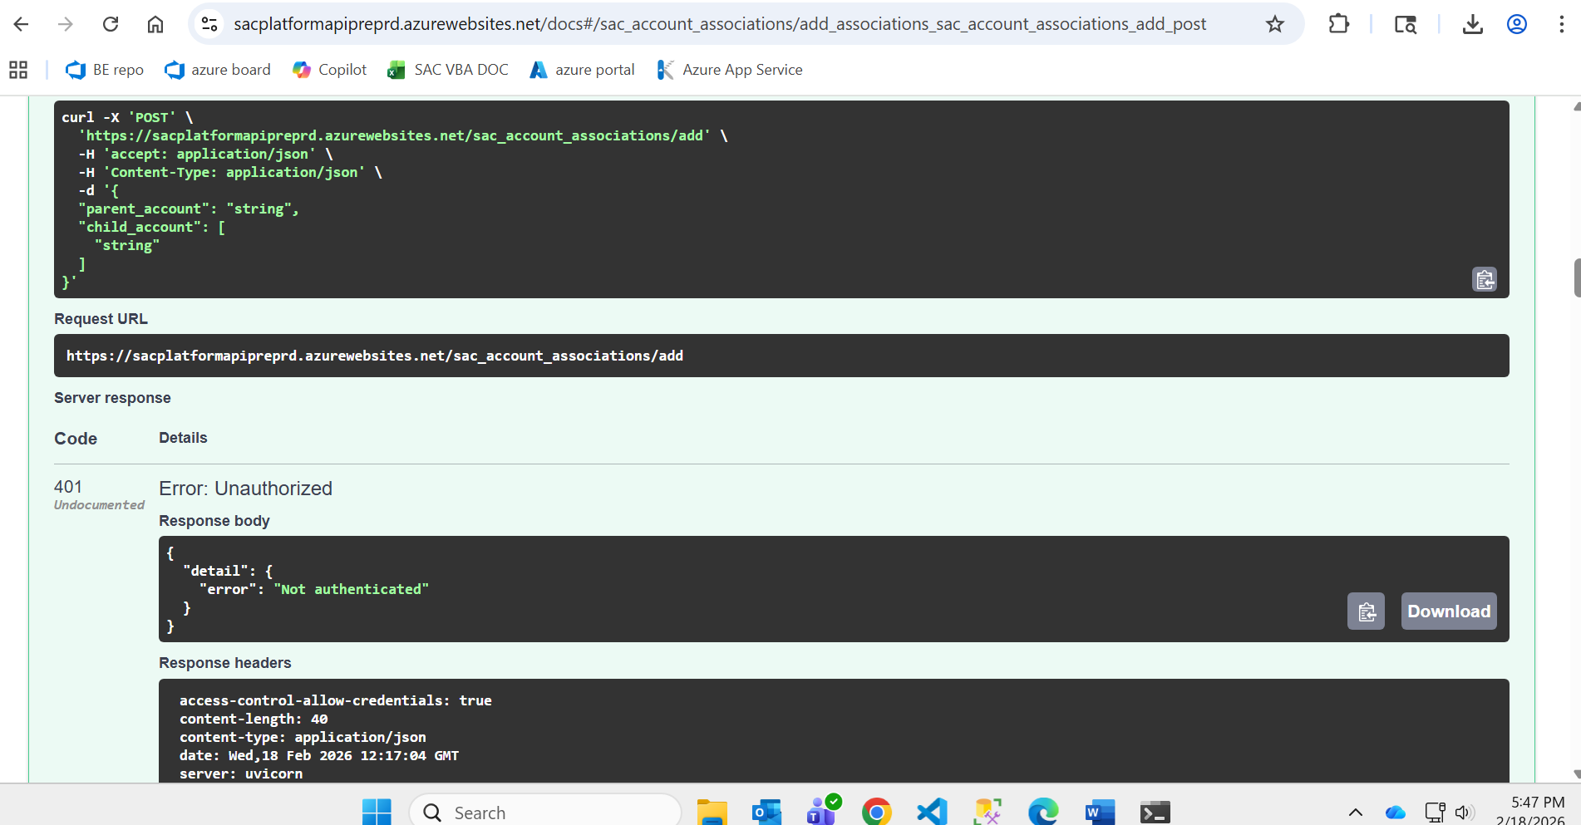

Swagger UI
All APIs have been validated using Swagger UI, which is provided as part of FastAPI’s built‑in interactive documentation. Swagger UI allows us to manually trigger API endpoints, review request/response structures, and verify both success and error scenarios.
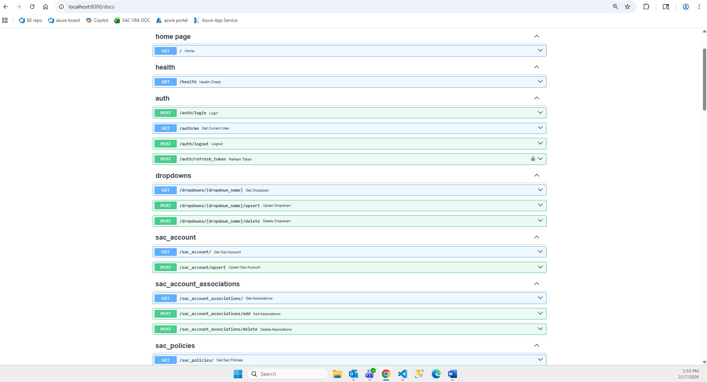

Example: Testing the /auth/login API
- Open Swagger UI in the browser.
- Navigate to the /auth/login endpoint and click the “Try it out” button.
- In the request body text area, provide a payload in the following format:
{
"email": "akshat@dummy.com",
"password": "12345678"
}
You may use any valid user credentials that already exist in the system.
- Click on “execute”. After execution, the response section will display the corresponding success response returned by the API.
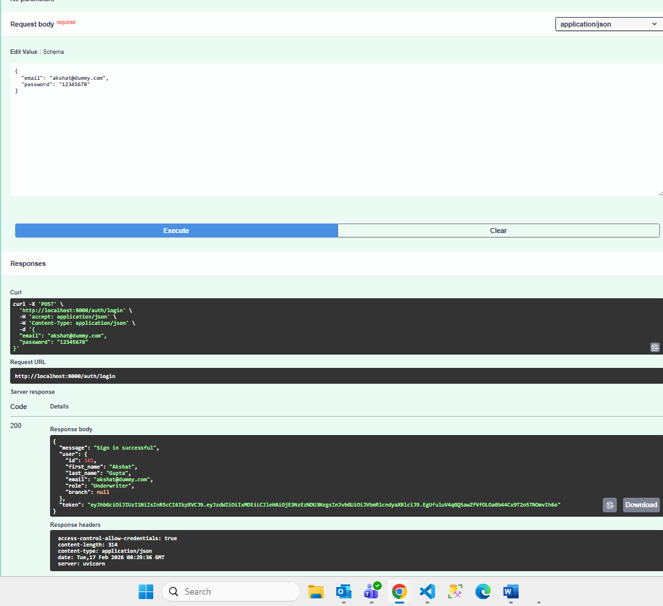

Error Handling Validation:
- When incorrect or invalid values are passed to the API—for example, an incorrect password—the API returns an appropriate error response as configured. This allows us to verify that validation, authentication logic, and exception handling work as expected. Below we have passed the wrong password:
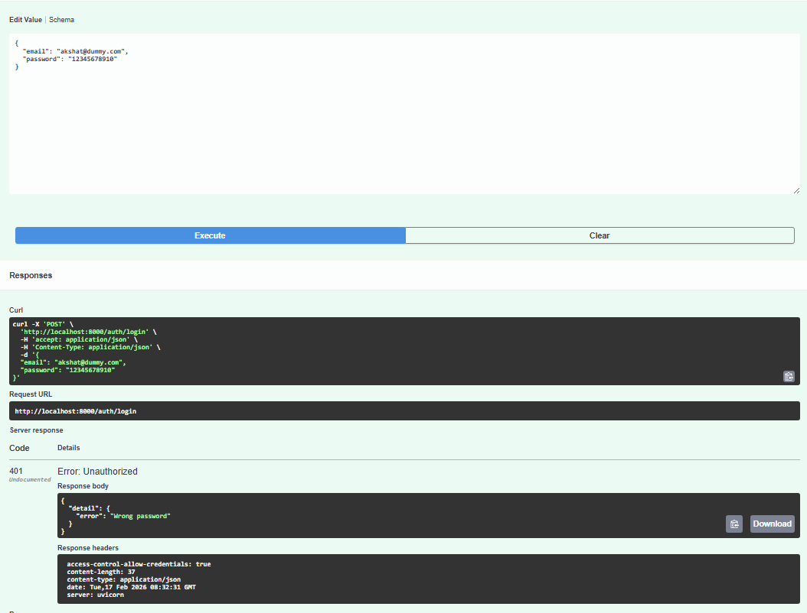
- If we pass details of user which doesn’t exist:
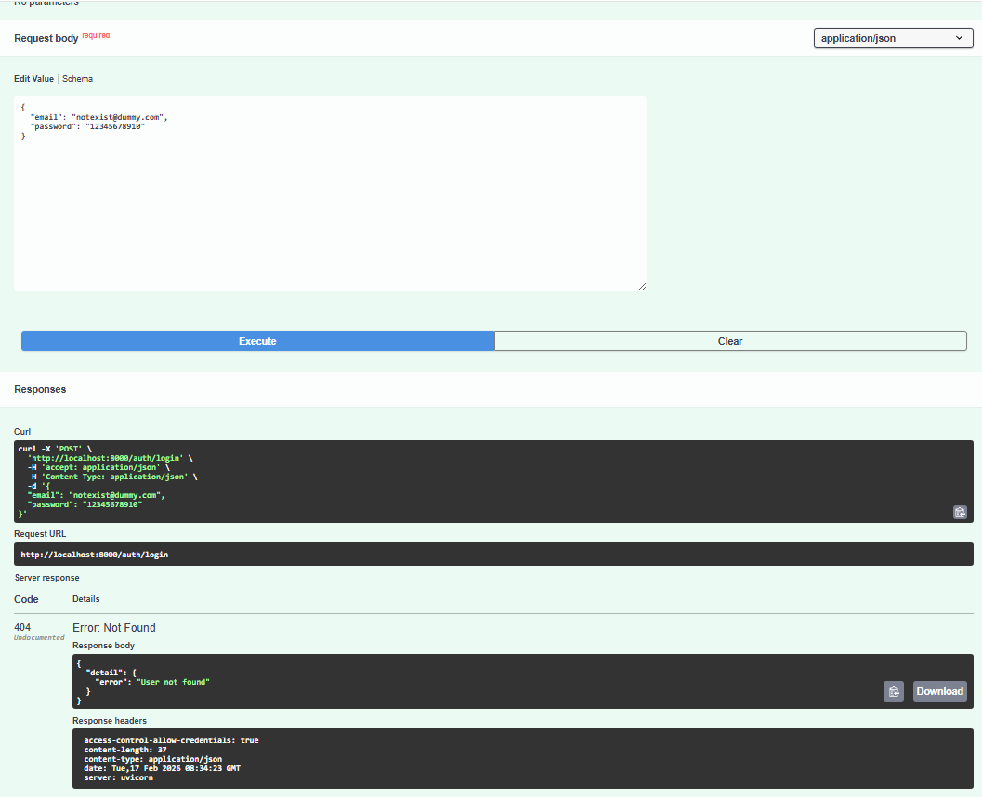

Using Swagger UI, we thoroughly tested all available API endpoints, validating:
- Successful execution paths
- Error responses for invalid input
- Authentication and validation behavior
- Response structure and status codes
This ensures that each API behaves consistently and reliably under both normal and erroneous conditions.

Load Testing

Objective
The purpose of the load testing was to validate the stability, reliability, and behavior of key SAC and Affinity APIs under increasing concurrent user load within the local development environment.

Test Scope and Methodology
- Load Testing Tool: Locust
- Output: HTML reports and performance trend charts
- Target Host: http://localhost:8000
- Scenario: Mixed GET/POST workload executed via the project’s locustfile.py, covering both SAC and Affinity endpoints
- Execution Pattern:
- Three incremental runs
- Final run ramped up to 125 concurrent users

Evidence Artifacts (Captured Reports & Charts)
The following files were generated during the executed runs:
- 10 user run
- 25 users run
- 125 users run
Below are the charts for Requests Per Second (RPS), Response time & Number of users:
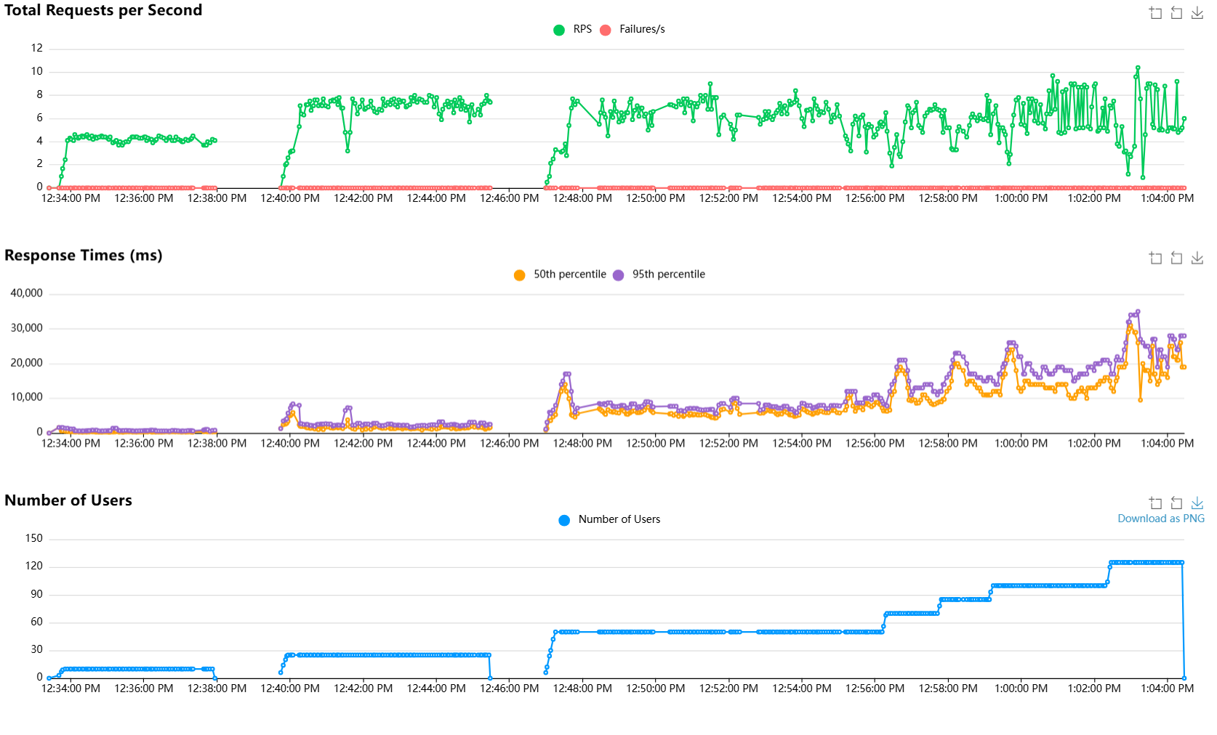

Run-by-Run Load Test Results

Run | Report File | Duration | Peak Users | Total Requests | Total Failures | Failure Rate | Avg Response (ms) | P95 (ms) | Total RPS
Run 1 | 10 users | 4 minutes and 15 seconds | 10 | 1058 | 0 | 0.00% | 403.53 | 780 | 4.16
Run 2 | 25 users | 5 minutes and 45 seconds | 25 | 2365 | 0 | 0.00% | 1581.28 | 2800 | 6.86
Run 3 | 125 users | 17 minutes and 29 seconds | 125 | 6319 | 0 | 0.00% | 9880.29 | 22000 | 6.02

Key Reliability Outcomes
- Total requests across all runs: 9,742
- Total API failures: 0
- Overall failure rate: 0.00%
- Stability: All tests—including the 125‑user peak—executed without any endpoint‑level failures.
- Error Handling: No exceptions or unhandled errors were reported in any Locust HTML export.
This confirms that all tested APIs remained operationally stable under simulated concurrent workload conditions.

Endpoint Reliability Snapshot (Final Run – 125 Users)

Method | Endpoint | Requests | Failures | Failure Rate | P95 (ms)
GET | GET /sac_policies | 665 | 0 | 0.00% | 23000
GET | GET /sac_account | 636 | 0 | 0.00% | 24000
GET | GET /auth/me | 501 | 0 | 0.00% | 7900
GET | GET /affinity_program | 490 | 0 | 0.00% | 24000
GET | GET /claim_review_frequency | 342 | 0 | 0.00% | 24000
GET | GET /affinity_policy_types | 341 | 0 | 0.00% | 21000
GET | GET /loss_run_frequency | 340 | 0 | 0.00% | 26000
GET | GET /claim_review_frequency_affinity | 334 | 0 | 0.00% | 21000
GET | GET /search_sac_account | 322 | 0 | 0.00% | 22000
GET | GET /affinity_agents | 320 | 0 | 0.00% | 24000
GET | GET /search_affinity_program | 318 | 0 | 0.00% | 23000
GET | GET /sac_policies/get_premium | 314 | 0 | 0.00% | 25000

Test summary and outcome
- The SAC and Affinity API suite demonstrated consistent and stable behavior across all executed load levels.
- No functional errors or API‑level failures occurred even as user load increased from baseline to 125 concurrent users.
- The test confirms proper handling of session flow, request processing, and application‑level logic under stress.
- Since the tests were executed in a local environment (limited hardware, single‑instance backend), production‑grade Azure infrastructure is expected to provide significantly stronger performance and lower latency.

Database & Migration Testing

Objective
The objective of Database & Migration Testing is to verify that all database objects, data values, metadata, constraints, indexes, and business‑critical relationships are fully and correctly migrated to Azure SQL Database, and that the migrated database behaves identically to the original on‑prem SQL Server in terms of application functionality, data integrity, and performance.

Migration Approach
As part of the migration from the on‑premises SQL Server database to the Azure SQL Managed Instance, we carried out comprehensive data migration testing to ensure that all schema objects and data were transferred accurately and completely.
A full backup and restore procedure were executed to migrate data from the on‑premises SQL Server environment to the Azure SQL Managed Instance. As part of this process, the complete database— including all tables, row data, and associated constraints—was successfully backed up from the source system and restored into the Azure environment. This ensured that the target database retained the full structure and content of the original system without any data loss or schema discrepancies.

Data Validation
To confirm that the migration is successful and no records will be lost or altered, we will perform row‑count validation on key tables before moving to production environment. This involves:
- Running COUNT(*) queries on selected tables in the source (on‑prem) database.
- Running the same COUNT(*) queries on the target (Azure SQL Managed Instance) database.
- Verifying that the row counts matched across environments.
This method provides a quick and reliable way to confirm that data has been fully and accurately migrated.
Below are the details of the tables which will be validated, and their respective record counts will be updated when we are moving to production:
Table Name | Total count in SQL DB - Production | Total count in Azure DB- Production
SAC TABLES
tblAcctSpecial
tblDistribute_ClaimReview
tblDistribute_DeductBill
tblDistribute_LossRun
tblLossRunFrequency
tblClaimReviewFrequency
tblDeductBillFrequency
tblHCMUsers
tblAffiliates
tblPolicies
AFFINITY TABLES
tblAcctAffinityProgram
tblDist_ClaimRev_AFFIN
tblDist_LossRun_AFFIN
tblClaimRevFreq_AFFIN
tblLossRunFreq_AFFIN
tblDIST_PolicyTypeScheduler_AFFIN
tblAffinityAgents
tblAffinityPolicyType

Utilities test
We have below utilities implemented to interact with azure DB. These utilities are well tested with different scenarios. Details are as followed:
Connection utilities (db.py):
- Build Azure SQL connection string from settings.
- Parse SQL DATETIMEOFFSET payloads to timezone-aware Python datetime.
- Open pyodbc connection and register the output converter.
- Close connections via context manager lifecycle.
Query/transaction utilities (core/db_helpers.py):
- Validate safe SQL identifiers and sanitize allow-listed filters.
- Build parameterized SELECT queries.
- Execute reads with JSON-safe null normalization.
- Execute MERGE upsert, INSERT, DELETE helper flows.
- Execute async wrappers using threadpool delegation.

Execution Summary
Command: pytest -q tests/core/test_db.py tests/core/test_db_helpers.py
Result: 19 passed in 1.55s
Coverage command: pytest --cov=db --cov=core.db_helpers --cov-report=term-missing tests/core/test_db.py tests/core/test_db_helpers.py
Coverage:
- db.py = 100%
- core/db_helpers.py = 82%
- combined = 85%

Function | Scenario | Expected Result | Evidence
db._build_connection_string | Builds connection string using configured driver/server/database/authentication. | String contains configured values and Encrypt/TrustServerCertificate flags. | Implemented in tests/core/test_db.py
db._handle_datetimeoffset | Parses 20-byte DATETIMEOFFSET payload. | Returns correct datetime, microseconds, and timezone offset. | Implemented in tests/core/test_db.py
db._handle_datetimeoffset | Parses offset-minutes DATETIMEOFFSET payload. | Returns datetime with correct offset in minutes format. | Implemented in tests/core/test_db.py
db._handle_datetimeoffset | Handles null/invalid payload. | Returns None without crashing. | Implemented in tests/core/test_db.py
db.get_raw_connection | Register output converter for DATETIMEOFFSET. | Converter registered with expected SQL type and handler. | Implemented in tests/core/test_db.py
db.get_raw_connection | Handles converter registration failure. | Connection is still returned if converter registration fails. | Implemented in tests/core/test_db.py
db.db_connection | Context manager connection lifecycle. | Connection is closed after context exits. | Implemented in tests/core/test_db.py
db_helpers.ensure_safe_identifier | Reject invalid identifier names. | Raises ValueError for unsafe identifier format. | Implemented in tests/core/test_db_helpers.py
db_helpers.sanitize_filters | Allow-list validation for filters. | Allowed fields pass; invalid fields are rejected. | Implemented in tests/core/test_db_helpers.py
db_helpers.sanitize_filters | Reject unsafe identifier in filters. | Raises ValueError for unsafe filter key. | Implemented in tests/core/test_db_helpers.py
db_helpers.build_select_query | Build SELECT with filters and ORDER BY. | Returns the expected SQL and parameter order. | Implemented in tests/core/test_db_helpers.py
db_helpers.build_select_query | Build SELECT without filters. | Returns base SELECT and empty params. | Implemented in tests/core/test_db_helpers.py
db_helpers.fetch_records | Fetch records with null handling. | NaN values converted to None in returned payload. | Implemented in tests/core/test_db_helpers.py
db_helpers.run_raw_query | Run raw SELECT with params. | Passes query/params correctly to read_sql. | Implemented in tests/core/test_db_helpers.py
db_helpers.merge_upsert_records | Build and execute MERGE upsert. | MERGE/ON/INSERT clauses and values are correct. | Implemented in tests/core/test_db_helpers.py
db_helpers.merge_upsert_records | Exclude key columns from insert when configured. | INSERT clause omits key columns when flag enabled. | Implemented in tests/core/test_db_helpers.py
db_helpers.insert_records | Build and execute INSERT query. | Parameterized INSERT statement is generated correctly. | Implemented in tests/core/test_db_helpers.py
db_helpers.delete_records | Build and execute DELETE with a composite key. | WHERE clause and parameter values are correct. | Implemented in tests/core/test_db_helpers.py
db_helpers.fetch_records_async | Async wrapper execution path. | Delegates to run_in_threadpool and return result. | Implemented in tests/core/test_db_helpers.py

Schema Validation
Schema validation was performed to ensure that the complete database structure required by the SAC application was accurately migrated from the on‑premises SQL Server environment to the Azure SQL Database. This process validated the equivalence of schema objects, metadata, and constraints between the source and target systems.
Objectives – What Schema Validation Ensures
1. Table/Object Parity
- All application‑relevant tables exist in the Azure SQL Database.
- No required table is missing or renamed.
2. Column‑Level Contract Parity
- Column names, data types, precision, scale, and maximum lengths match.
- Nullability, identity properties, and default/computed column logic are preserved.
3. Constraint Parity
- Primary Keys (PK), Foreign Keys (FK), Unique constraints (UQ), and Check constraints (C) are functionally equivalent between source and target.
4. Index Parity
- All required indexes exist in Azure SQL Database.
- Index structure—key columns, included columns, uniqueness, and filters—is consistent.
Practical Execution – Step‑by‑Step Validation Process
Step 1: Environment Setup
- Open SQL Server Management Studio (SSMS) or Azure Data Studio.
- Create:
  - Connection A: On‑prem SQL Server (source)
  - Connection B: Azure SQL Database (target)
Step 2: Validate Required Tables
Run the following query in both source and target environments:
SELECT t.name AS table_name FROM sys.tables AS t WHERE t.name IN (
'tblAcctSpecial','tblPolicies','tblAffiliates','tblHCMUsers','tblSACAccountAssociations',
'tblLossRunFrequency','tblClaimReviewFrequency','tblDeductBillFrequency',
'tblDistribute_LossRun','tblDistribute_ClaimReview','tblDistribute_DeductBill',
'tblAcctAffinityProgram','tblAffinityAgents','tblAffinityPolicyType', 'tblLossRunFreq_AFFIN','tblClaimRevFreq_AFFIN','tblDist_LossRun_AFFIN','tblDist_ClaimRev_AFFIN','tblDIST_PolicyTypeScheduler_AFFIN','tblDropDowns','tblUsers','tblMGTUsers', 'tblLossCtrl','tblBranch','tblServiceLevel','tblUnderwriters','tblEDW_AGENT_LIST')
ORDER BY t.name;

Expected Result:
Both environments return identical lists of tables.

Step 3: Column‑Level Validation (Example: tblPolicies)
Run in both environments:

SELECT c.column_id, c.name AS column_name, ty.name AS data_type,
c.max_length, c.precision, c.scale, c.is_nullable, c.is_identity,
ISNULL(dc.definition, '') AS default_definition,
ISNULL(cc.definition, '') AS computed_definition,
ISNULL(c.collation_name, '') AS collation_name
FROM sys.tables t JOIN sys.columns c ON c.object_id = t.object_id
JOIN sys.types ty ON ty.user_type_id = c.user_type_id
LEFT JOIN sys.default_constraints dc ON dc.parent_object_id = c.object_id
AND dc.parent_column_id = c.column_id LEFT JOIN sys.computed_columns cc
ON cc.object_id = c.object_id AND cc.column_id = c.column_id
WHERE t.name = 'tblPolicies’ ORDER BY c.column_id;

Expected Result:
Column definitions match between source and target.

Step 4: Constraint Validation (Example: tblPolicies)

SELECT o.type_desc AS constraint_type, o.name AS constraint_name
FROM sys.objects o JOIN sys.tables t ON t.object_id = o.parent_object_id
WHERE t.name = 'tblPolicies' AND o.type IN ('PK','UQ','F','C')
ORDER BY o.type_desc, o.name;

Expected Result:
Primary Key, Foreign Key, Unique, and Check constraints are equivalent.

Step 5: Index Validation (Example: tblPolicies)

SELECT i.name AS index_name, i.type_desc,i.is_unique, i.has_filter,
ISNULL(i.filter_definition, '') AS filter_definition, ic.key_ordinal, ic.is_included_column,
c.name AS column_name
FROM sys.tables t JOIN sys.indexes i ON i.object_id = t.object_id
JOIN sys.index_columns ic ON ic.object_id = i.object_id
AND ic.index_id = i.index_id JOIN sys.columns c ON c.object_id = ic.object_id
AND c.column_id = ic.column_id WHERE t.name = 'tblPolicies'
AND i.is_hypothetical = 0 ORDER BY i.name, ic.key_ordinal, ic.is_included_column, c.name;

Expected Result:
All expected indexes exist with correct key order and include structure.

Schema Validation – Pass/Fail Criteria
Pass Criteria
- No missing in-scope tables in Azure SQL Database
- No unresolved column definition mismatches
- PK/FK/UQ/Check constraints are equivalent
- All required indexes match and support production queries

Fail Criteria
Any unresolved mismatch that impacts:
- Application behavior
- Data integrity
- System performance

Data Correctness Sampling
Data correctness sampling is performed to validate that individual row‑level values were migrated accurately from the on‑premises SQL Server database to the Azure SQL Database. This approach ensures that the migration preserved not only schema and row counts but also the actual business data used by the SAC application.
Objectives – What Data Correctness Sampling Validates
1. Value Correctness
- Confirms that source and target rows contain identical values across critical data fields.
2. Data Quality Dimensions Covered
- Null value handling
- Date and datetime accuracy
- Monetary/decimal precision
- Text and business‑key consistency

Sampling Model Used for Validation
Sampling was designed based on data volume and business relevance:
High Priority Entities for Row‑Level Comparison
- tblAcctSpecial
- tblPolicies
- tblAffiliates
- tblSACAccountAssociations
Sampling Rules
- 100% comparison for low/medium‑volume critical entities.
- Deterministic sampling (e.g., 10%) for high‑volume tables using CHECKSUM modulo logic to ensure identical source/target sample selection.
- Business‑relevant filters applied:
  - Stage = 'Admin'
  - IsSubmitted = 1
  - PolicyStatus = 'Active'
This method ensures sampling is representative, repeatable, and fully aligned with how the SAC application consumes data.
Step 1: Environment Setup
- Open SQL Server Management Studio (SSMS) or Azure Data Studio.
- Create:
  - Connection A → On‑prem SQL Server (source)
  - Connection B → Azure SQL Database (target)
Step 2: Execute Sampling Query – tblAcctSpecial
Run the following query in both environments, exporting each to separate CSV files:
- source_tblAcctSpecial_sample.csv
- target_tblAcctSpecial_sample.csv

SELECT CustomerNum, CustomerName, OnBoardDate, ServLevel, AcctStatus,
CONVERT(varchar(64), HASHBYTES('SHA2_256', CONCAT(
ISNULL(CAST(CustomerNum AS nvarchar(100)), '<NULL>'), '|',
ISNULL(CustomerName, '<NULL>'), '|',
ISNULL(CONVERT(nvarchar(30), OnBoardDate, 126), '<NULL>'), '|',
ISNULL(ServLevel, '<NULL>'), '|',
ISNULL(AcctStatus, '<NULL>') )), 2) AS row_hash FROM dbo.tblAcctSpecial
WHERE Stage = 'Admin' AND IsSubmitted = 1 AND ABS(CHECKSUM(CustomerNum)) % 10 = 0 ORDER BY CustomerNum;

Expected Result:
For all business keys selected, row_hash values match between source and target.

Step 3: Compare Extracts
Quick Comparison (Excel / Power Query)
- Join source and target CSVs on business keys.
- Compare row_hash values.
Pass/Fail Criteria for Data Correctness Sampling
Pass Conditions
- No missing keys in sampled datasets (unless approved exceptions exist)
- No unresolved row_hash mismatches
- No incorrect premium, date, or status values in policy samples
- All discrepancies are resolved or documented
Fail Conditions
- Any unresolved mismatch that may impact:
  - API search results
  - Reporting totals
  - Account or policy integrity
  - Business workflows

Security Testing:
To ensure the security and integrity of the application, several security measures have been implemented and validated. The testing focused on verifying that authentication and authorization mechanisms function as intended, and that access is properly controlled throughout the system.
Authentication:
Authentication for the application is managed through F5 in combination with Azure Active Directory (Azure AD) groups. This setup ensures that only legitimate, directory‑authenticated users are granted access to the application.
For detailed implementation information, refer to Section 6.5 of SAC migration document.
Authorization:
Authorization is enforced using Azure AD security groups, which control the level of access granted to authenticated users.
Each role or permission set within the application corresponds to specific Azure AD groups, ensuring that access is provided strictly on a need‑to‑have basis.
For more information on the authorization design and group configurations, see Section 6.4.a. of SAC Migration Document.
Input validation:
Extensive input validation has been implemented throughout the application to ensure data accuracy, enforce business rules, and maintain consistency with the legacy VBA application. All fields that previously required validation in the VBA system have been validated in the new application as well. Example Scenario:
Business Requirement:
When an account is marked as “inactive”, the user must provide the following mandatory details:
- Termination Date
- Termination Reason
- Notification Date

Validation Flow:
- Login to the SAC application.
- Set an account's status to Inactive.
- Attempt to save the form without entering the Termination Date.
- The system displays an appropriate error message, and the missing required field is visually highlighted (e.g., the Termination Date field appears with a red border).
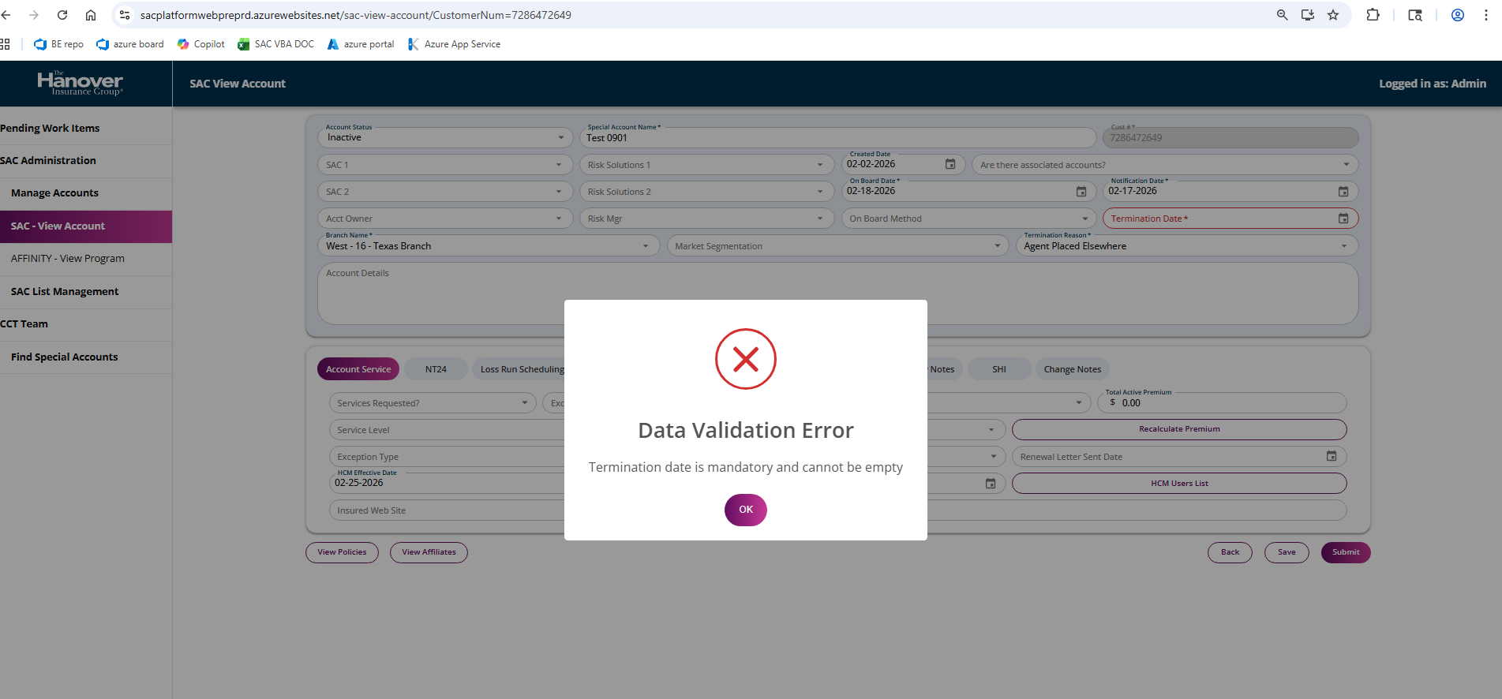
This ensures that users cannot proceed without providing the required information, maintaining the integrity of the data.
Besides status‑based validations, the application also enforces checks on:
- Numeric fields
- Email format validation
- Required dropdown selections
- Context‑based field requirements
- Cross‑field validation rules (where applicable)
These validations collectively ensure that user input is complete, accurate, and aligned with defined business rules before any data is processed or saved.
Secrets management:
All application secrets have been securely stored and managed using Azure Key Vault. This ensures that sensitive information—such as database connection strings, API keys, certificates, and authentication secrets—is isolated from the application code and protected using Azure’s built‑in security controls.
For additional implementation details, configuration steps, and integration workflows, please refer to Section 6.3 of SAC Migration Document.

Integration Testing:
As part of integrating the React and Python-based application into the Azure environment, operational checks and monitoring mechanisms were implemented. These measures help assess the application's health, ensure high availability, and provide automated alerts in case of service degradation or failures.

/health API endpoint
A dedicated /health endpoint has been implemented to support automated health monitoring. This endpoint plays a critical role in maintaining the application's uptime by enabling Azure to identify and remove unhealthy instances from the load balancer.
Key Behaviors:
- Azure periodically (once per minute) sends a request to the /health endpoint.
- If the endpoint consistently returns HTTP 200, the application instance is considered healthy.
- If the endpoint returns any non‑200 response, it is flagged as unhealthy.
- A continuous failure period of 10 minutes triggers Azure to:
  - Mark the instance as unhealthy
  - Remove it from the load balancer
  - Automatically replace it with a new instance
This mechanism ensures minimal user impact by quickly isolating failing instances and maintaining overall application reliability.
